**Global Terrorism Dashboard**

**Description:**

The Terrorism Database contains information about terrorist attacks worldwide. It includes details such as the date, location, attack type, weapons used, number of casualties, and responsible groups. Your task is to create a Power BI dashboard that provides a comprehensive overview of global terrorism trends and patterns.

Dataset: Terrorism Dashboard

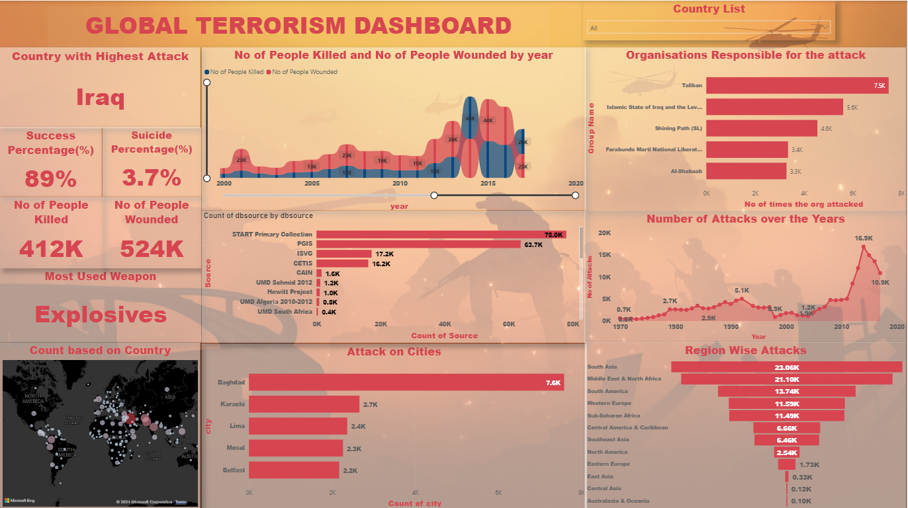

Key Findings:

* **Iraq** is the most attacked Country.
* **Bagdad** is the city with most attacks
* Succes Percentage is **89%** which is concerning
* Suicide Percentage is **3.7%**
* **Taliban** is the organization responsible for most attack.
* **Explosives** is the most used weapon.
* **2014** is the year with most attacks.
* **412K** People died and **525K** people wounded this shows the consequences of war.